ALBERT BANDURA

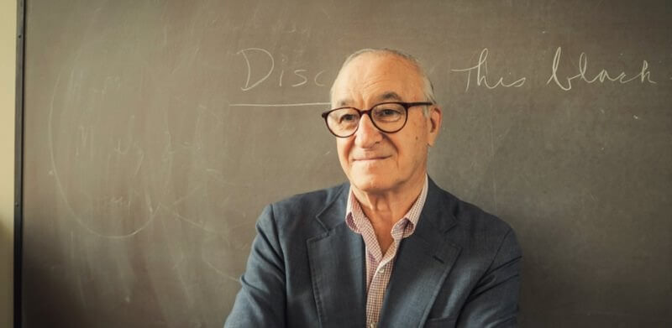

Albert Bandura, one of the few icons on our list still living at the time of writing, is responsible for enormous contributions to the fields of psychology and education. Indeed, at 93 years of age (at the time of writing), Bandura is the most cited living psychologist. His greatest contributions have been in the areas of social and personality psychology. Bandura developed the highly influential social learning theory — the idea that we learn new behaviors by observing others in social settings — and by extension, social cognitive theory — the idea that we also acquire knowledge as a consequence of observing others through social interaction, engaging in our own social interaction, and even through media.

Bandura was a key figure in helping push the field of psychology from Skinner’s behaviorist model to cognitive psychology. His Bobo doll experiment, conducted in 1961, was considered a groundbreaking examination of social learning theory. Here, Bandura measured the impact on children who observed adults behaving aggressively toward a rocking “Bobo doll.” The goal was to demonstrate that behaviors are learned through observation, and that witnessing adults being punished or rewarded for certain actions can have a profound impact on how children behave. At the heart of Bandura’s theory was that children who observed violent behavior that was either rewarded, or which did not elicit punishment, were themselves more likely to engage in violent behavior. Bandura also introduced important concepts relating to personality psychology, perhaps most significant among them being self-efficacy. This refers to an individual’s own belief in their ability to master skills, reach certain achievements, and rebound from setbacks. An individual’s degree of self-efficacy can have a strong impact on personality development and behavior.

WILLIAM JAMES

Sometimes identified as the Father of American psychology, James was the very first educator to offer a psychology course in the U.S. 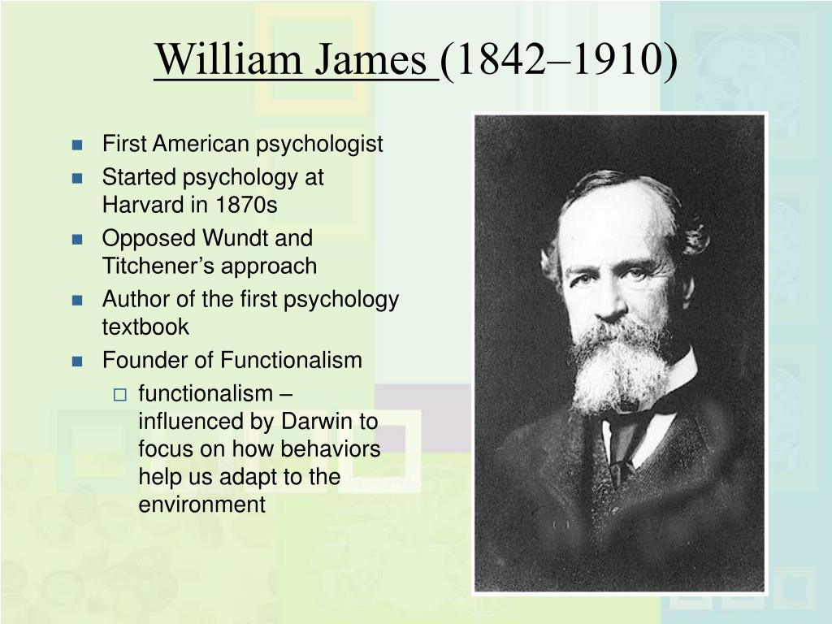As one of the foremost philosophers and thinkers of the 19th Century, James enjoys a sterling reputation in modern psychology. He is considered one of the founding figures in functional psychology — a counterpoint to structuralism that attributes human behavior to Darwinian impulses of survival and utility. He argued that, for each of us, true beliefs are those which prove useful to the believer. That is, we are driven to perceive truth based on pragmatic impulses, those that best serve our needs, desires, and interests. This framework, along with James’ emphasis on human pragmatism, helped to usher in a new era of empirically-driven psychology in the U.S.

JEAN PIAGET
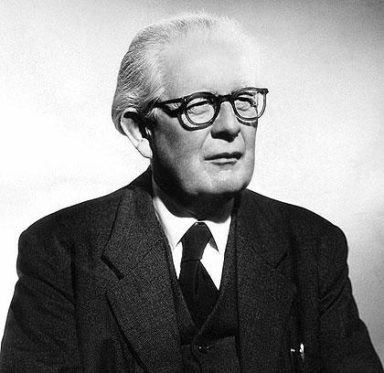
Jean Piaget was a Swiss psychologist and genetic epistemologist. He is most famously known for his theory of cognitive development that looked at how children develop intellectually throughout the course of childhood.
Jean Piaget was a Swiss psychologist and genetic epistemologist. He is most famously known for his theory of cognitive development that looked at how children develop intellectually throughout the course of childhood.

Prior to Piaget's theory, children were often thought of simply as mini-adults.¹﻿ Instead, Piaget suggested that the way children think is fundamentally different from the way that adults think. Piaget's theory had a tremendous influence on the emergence of developmental psychology as a distinctive subfield within psychology and contributed greatly to the field of education. He is also credited as a pioneer of the constructivist theory, which suggests that people actively construct their knowledge of the world based on the interactions between their ideas and their experiences.

Piaget was ranked as the second most influential psychologist of the 20th century in one 2002 study.

